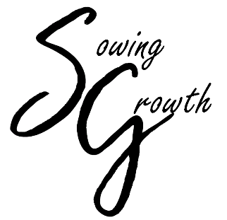
Eastern Ingham Farmers Market
Sundays 10 am – 2 pm Mid-May to Mid-October
Pollination Station Application
A community outreach booth space application

RULES AND REQUIREMENTS FOR USE OF THE POLLINATION STATION

Sowing Growth, the non-profit that operates the Williamston Farm & Artisan Market (WFAM), is proud to offer the Market as a resource to community-based service organizations. One market booth/space is made available each week at no cost for groups with a stated mission to enhance the community or conduct educational outreach. To apply for use of the booth, complete the “Pollination Station” Booth Application.

Advanced Scheduling is Required.
- There is no fee for the use of the booth by approved applicants.
- Only one organization/group may use the booth per day.
- No sales are permitted from the booth.
- The booth is not to be used as a forum for political, commercial, or religious activities. Use of the booth is not available to organizations with a 501c4 tax status.
- The decision to approve a Community Outreach booth application shall be at the sole discretion of the WFAM Manager.
- Organizations desiring to use the booth on more than one date should list all dates on the application so that WFAM can evaluate space availability and make assignments accordingly.
- Each organization/group is responsible for the set-up and breakdown of the booth.
- Each organization/group is responsible for providing all booth equipment, furnishings, and signage on the day of use.
- Except for booth fees, the requesting organization/group is subject to all Market Rules and Regulations (posted on the WFAM website) as established by Sowing Growth and WFAM. Set-up must be completed before the Market opens, or the space may be reassigned.
- Information may be handed out from the designated booth area only.
- No microphone or bullhorns permitted.
- Organizations/groups may participate in free games, quizzes, or other activities promoting public participation.
- Interaction with shoppers and visitors is strongly encouraged. (Showing up and sitting in a chair and just watching people walk by defeats the purpose of reserving the booth)

Return the completed form to:
Perry Youngs
WFAM Market Manager
P.O. Box 534, Williamston, MI 48895
Email: marketmanager@sowinggrowth.org
Telephone: (517) 231-2124

Sowing Growth and WFAM strive to provide a venue for consumers to access the produce and product offerings of local farmers, artisans, and small businesses in the Williamston area. The opportunity for area residents and visitors to engage in sustainable commerce and social interaction with local farmers, entrepreneurs, and community members while supporting the local economy enhances the quality of life in the Williamston community.

